Assignment 2

Title – Jugad (Internet)

1. Finding size of Fruits

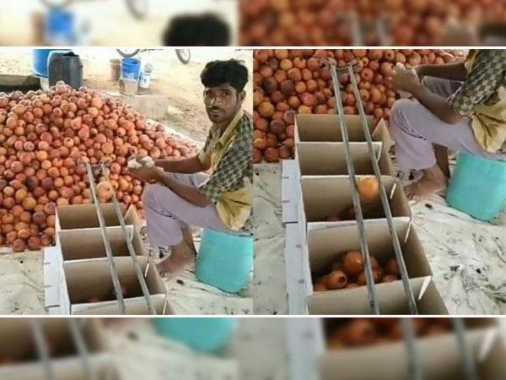

Source - www.indiatimes.com

Jugad – The pipes are placed in such a way that the gap between them goes on widening thus the fruits will fall inside the different crates sorted for different sizes, this helps the sellers to sell the same fruit for different prices.

2. The Mosquito Killer

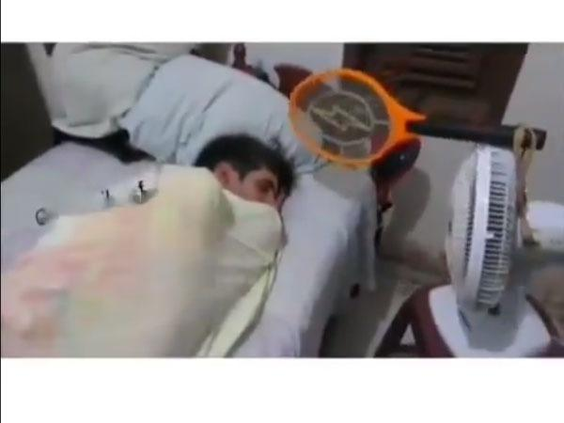

Source - www.indiatimes.com

Jugad – The electric racket is attached to a table fan which rotates 180 degrees thus keep the person sleeping cool and also killing the mosquitos which fly around him.

3. No Shower No Problem

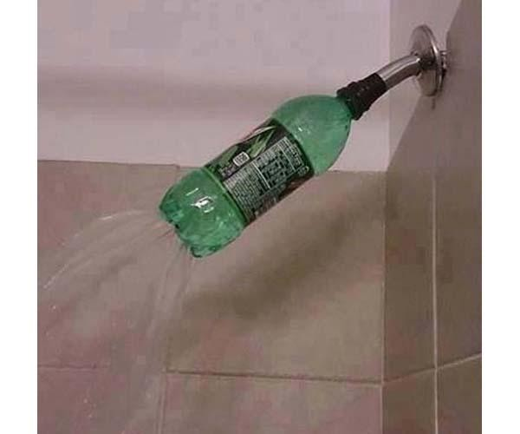

Source – www.indianexpress.com

Jugad – The plastic bottle is used to give a feel of shower. There are multiple holes below the bottle which pour down water like a shower.

4. Who needs a pillow

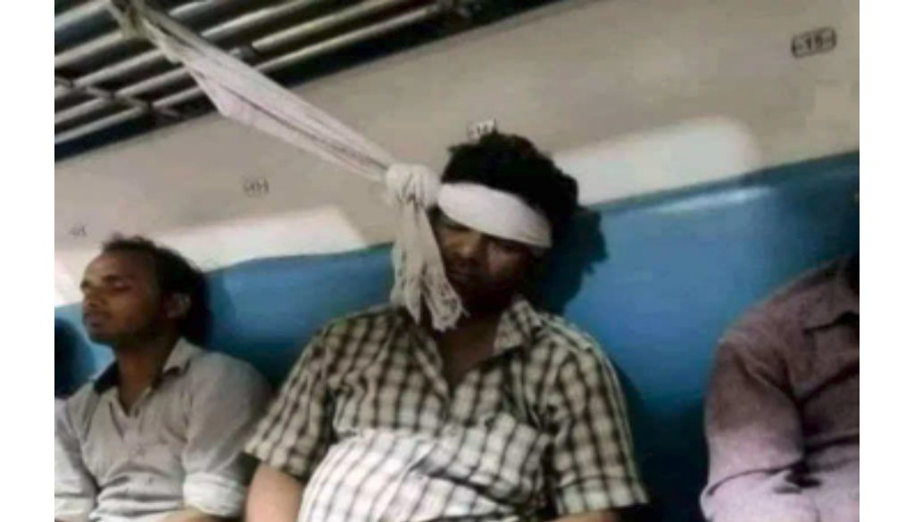

Source – Google Images

Jugad – the man has tied his head to a dupatta and then tiead the dupatta to to the bag rack so that he can sleep without falling down or without falling on someone.

5. New Locking System

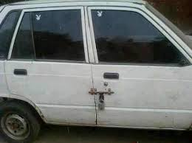

Source – Google Images

Jugad – the car door lock seems broken so instead of fixing it the person used latch lock to lock the car doors.

